**Q19. Employee Names**

Write a query that prints a list of employee names (i.e.: the name attribute) from the Employee table in alphabetical order.

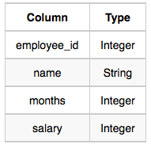The Employee table containing employee data for a company is described as follows:

where employee_id is an employee's ID number, name is their name, months is the total number of months they've been working for the company, and salary is their monthly salary.

**Sample Input**

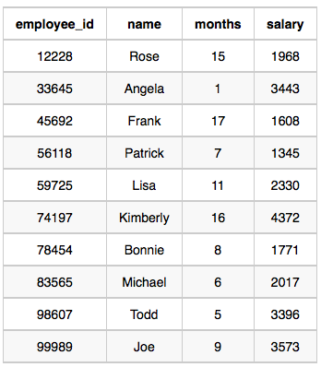

**Sample Output**

Angela

Bonnie

Frank

Joe

Kimberly

Lisa

Michael

Patrick

Rose

Todd

**Ans**.

SELECT NAME

FROM EMPLOYEE

ORDER BY NAME